

KAUNAS UNIVERSITY OF TECHNOLOGY

FACULTY OF INFORMATICS

T120B166 Development of Computer Games and Interactive Applications

*Run For Fun*

|  |
| --- |
| *IFF-0/4 Dainius Juškys* |
|  |
| Date: *2023/03/07* |

Kaunas, 2023

Tables of Contents

Tables of Images 4

Table of Tables/functions 5

Description of Your Game 6

Laboratory work #1 7

List of tasks 7

Solution 7

Task #1. *Movement* 7

Task #2. *Multiplayer* 8

Task #3. *Models* 9

Laboratory work #2 11

List of tasks 11

Solution 11

Task #1. *Environment revamp* 11

Task #2. *Shaders* 12

Task #3. *New mechanic* 13

Task #4. *Invisibility* 14

Laboratory work #3 16

List of tasks 16

Solution 16

Task #1. *Dash ability* 16

Task #2. *New Icons* 16

Task #3. *Particle system* 17

User's manual 19

Literature list 20

ANNEX 21

# **Tables of Images**

Figure 1. Movement demonstration 6

Figure 2. Multiplayer demonstration 7

Figure 3. Building model 8

Figure 4. girl Model 9

Figure 5. New environment 10

Figure 6. Shader 11

Figure 7 Shader graph 12

Figure 8. Screenshot of player going up the force stream 12

Figure 9. Screenshot of a player getting blasted off 13

Figure 13. Screenshot #5 18

Figure 14. Screenshot #5 18

# **Table of Tables/functions**

Table 1. Movement script 7

Table 2. Multiplayer code 8

Table 6. Updated movement script snippet 13

Table 6. Invisiblity code 14

Table 7. Dash code fragment 15

Table 8. Code of the icon cooldown 16

# **Description of Your Game**

Description of Your Game.

1. 3D or 2D? *It’s a 3D game*
2. What type is your game? *It’s a multiplayer tag game*
3. What genre is your game? *Casual sports game*
4. Platforms (mobile, PC or both?) *PC and mobile*
5. Scenario Description.

The two players are placed in a small arena. The goal of the game is for one player to "tag" the other player, while the other player tries to avoid being tagged.

At the start of the game, one player is designated as the "tagger," while the other player is the "evader." The tagger must try to touch the evader while the evader must try to stay out of reach.

Players can move around freely within the arena, and they can use a variety of strategies to tag or avoid being tagged. For example, they might climb the designated walls, use the environment to their advantage, or try to tire out the tagger by leading them on a chase.

If the tagger successfully tags the evader, they switch roles and play another round. If the evader manages to avoid being tagged for a set amount of time, such as one minute, they gain the point. The winner is the one who gets 5 points first.

**Laboratory work #1**

**List of tasks** (main functionality of your project)

1. Movement
2. Multiplayer
3. Models

# **Solution**

## **Task #1. *Movement***

The game has third person movement. Rotation is controlled with mouse/screen, while movement keyboard(AWSD)/joystick. The characters can walk, run, jump and climb walls.

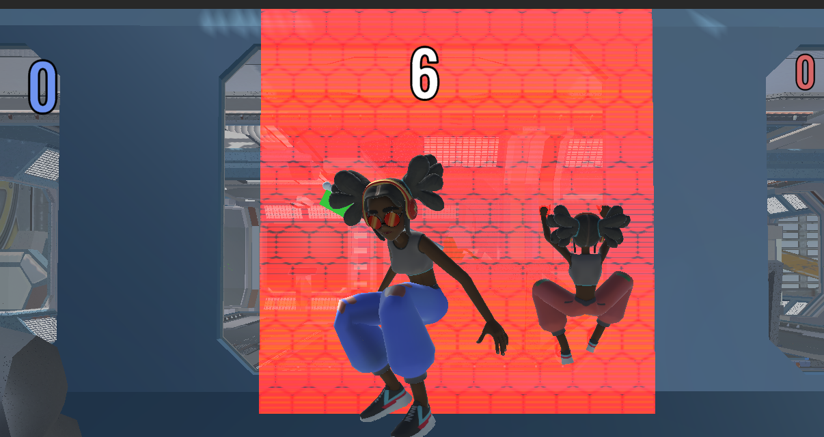

Figure 1. Movement demonstration

|  |  |
| --- | --- |
| Code screenshot | Explanation |
|  | **Movement script:**  **Client_ClimbOnTopOfTheWall**: my function that interrupts character movement to finish climbing the wall.  **Client_WallClimb:** my function that transforms normal movement to wall movement.  **Client_Movement**: Unity’s provided movement script with some additions.  **Client_CheckForWall:** my function that checks if there is wall infront.  **SetVisualsOfTheClientToTheServer();** my function that sends the current animation data to the server  **ClientVisuals():** my function that replicates the animations that get sent by the server. |

Table 1. Movement script

## **Task #2. *Multiplayer***

Using Unity Transport and their Relay servers, a multiplayer is able to be created in Unity. Unity Transport is a networking solution developed by Unity that enables developers to create multiplayer games and applications across multiple platforms, including PC, consoles, and mobile devices.

One of the key features of Unity Transport is its ability to utilize Relay servers. These servers act as intermediaries between clients, allowing players to connect and communicate with each other even if they are behind firewalls or using different network configurations.

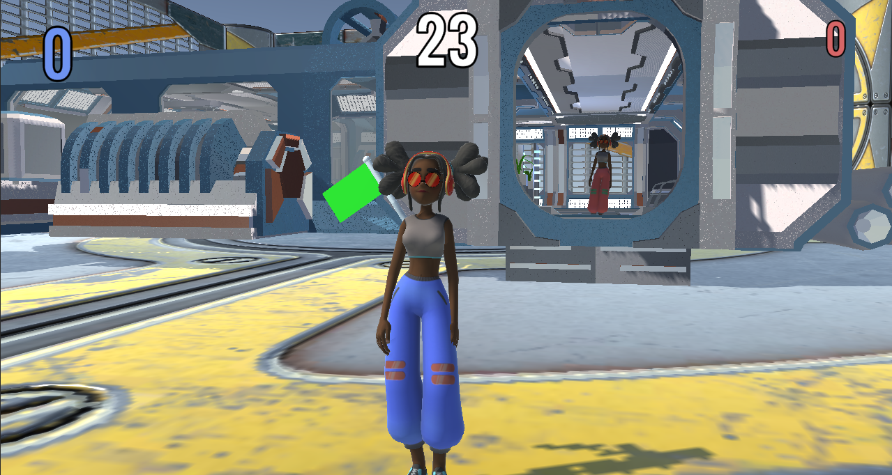

Figure 2. Multiplayer demonstration

|  |  |
| --- | --- |
| Code |  |
| Explanation | Multiplayer is made by each player sending their player’s data(position and rotation) to Unity’s servers which then each client gets and replicates the movement on their own machine.  I’m using Unity’s provided multiplayer code with some adaptations. |

Table 2. Multiplayer code

## **Task #3. *Models***

The whole game is using two main models which are taken from the free internet sources:

The main character - <https://www.mixamo.com/#/?page=2&type=Character>

Building - https://free3d.com/

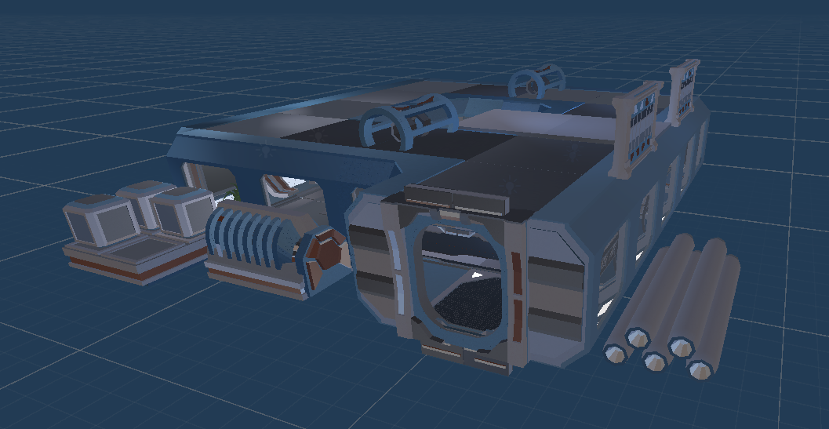

Figure 3. Building model

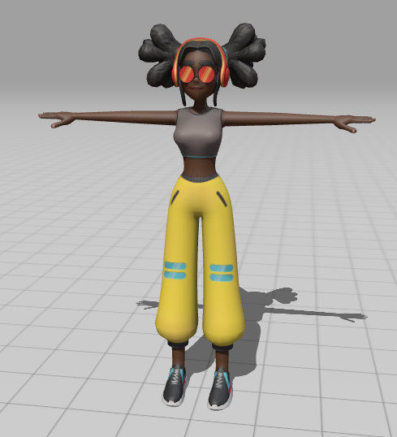

Figure 4. girl Model

**Laboratory work #2**

**List of tasks** (main functionality of your project)

1. Environment revamp
2. Shaders
3. New mechanic
4. Invisiblity

# **Solution**

## **Task #1. *Environment revamp***

The whole environment was changed to space. Including new HDRI and custom made planets.

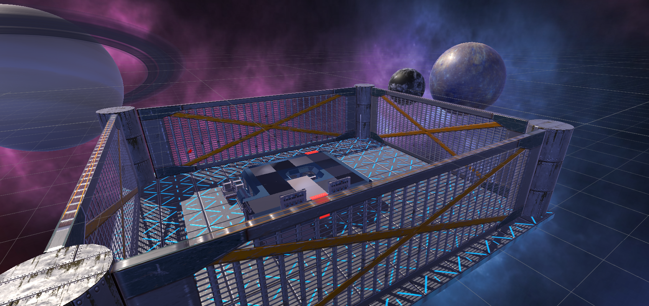

Figure 5. New environment

## **Task #2. *Shaders***

A custom made shader was created to visualize an upward force. The shader was created by watching a “Gabriel Aguiar Prod.” YouTube tutorial.

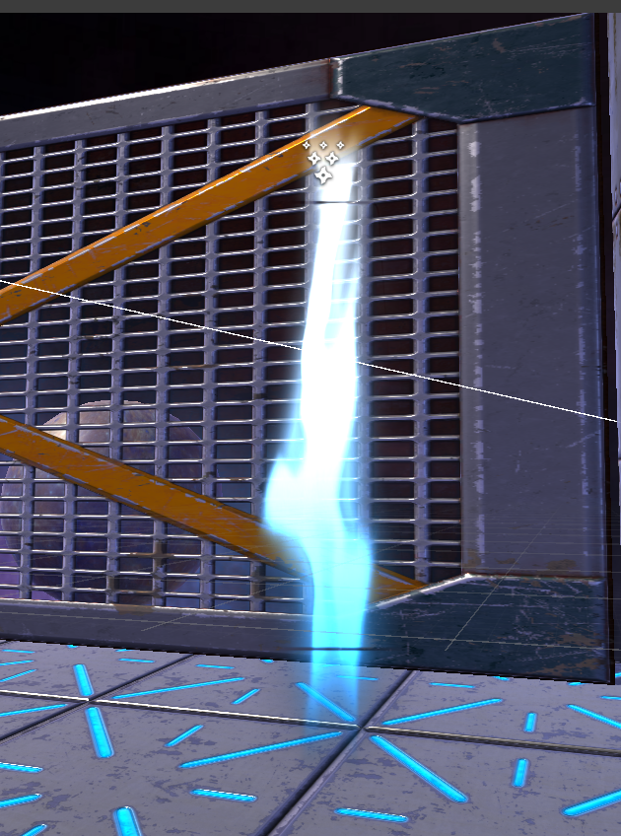

Figure 6. Shader

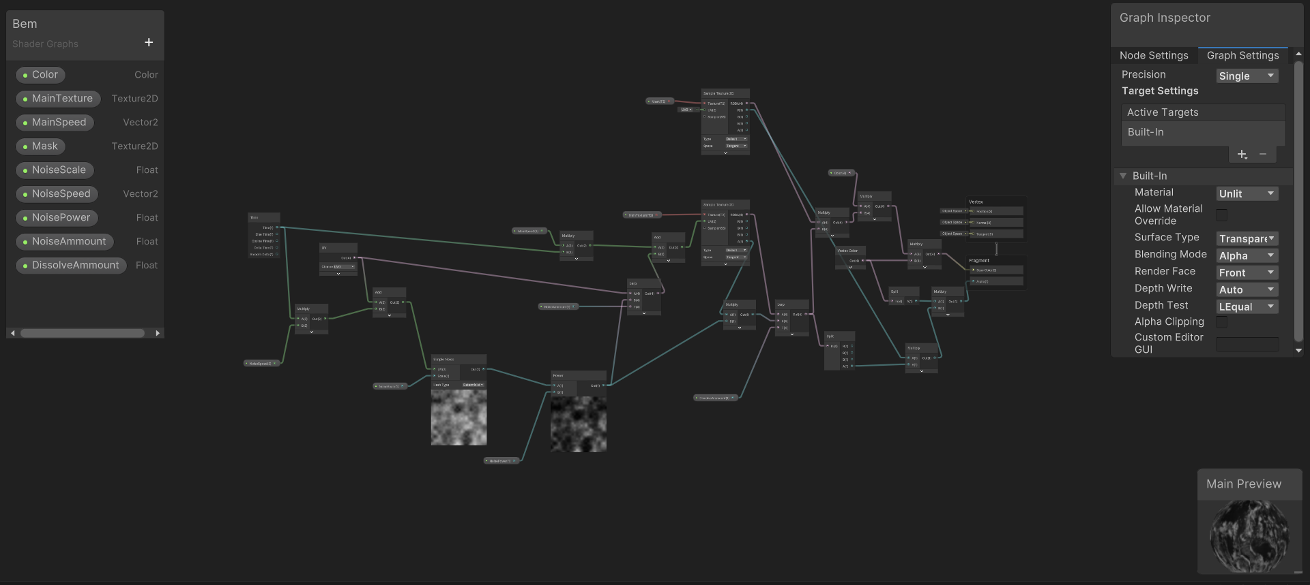

Figure 7 Shader graph

## **Task #3. *New mechanic***

A new mechanic was added. An ability to go up the stream of force and have it blast you off in chosen direction. It adds another way of dodging the chaser and improving the chances of winning.

The whole mechanic is split into two parts: 1) When player gets near the beam, he can choose to go up. If he does, the player will be elevated at a constant rate until it hits the top. He also is able to rotate while going up. 2) When player reaches the top, he gets blasted off the opposite direction he is facing. The direction where he will be blasted off can be controller while going up the beam.

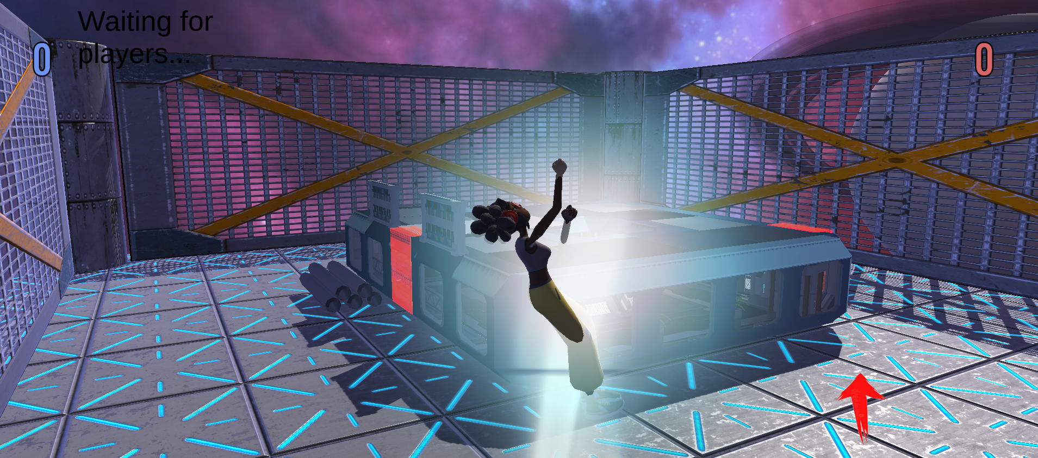

Figure 8. Screenshot of player going up the force stream

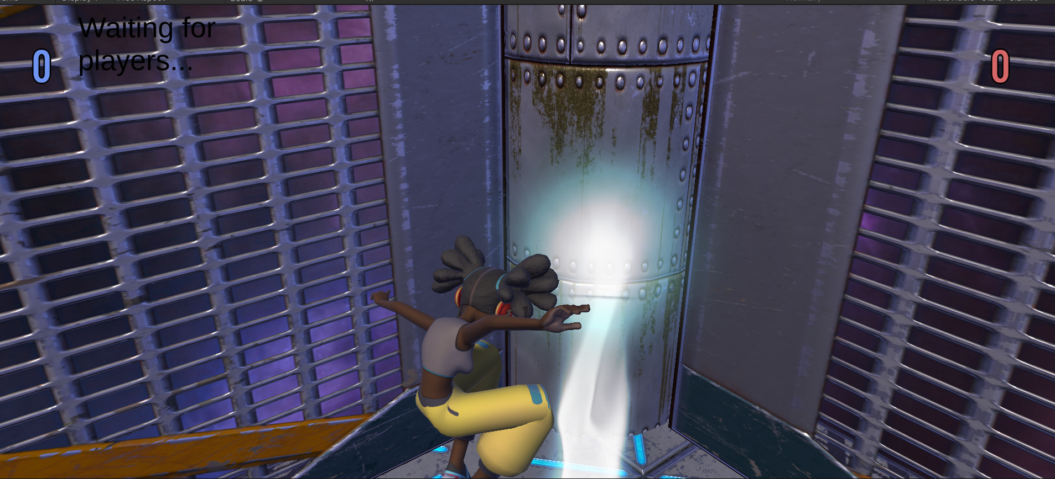

Figure 9. Screenshot of a player getting blasted off

|  |  |
| --- | --- |
| Code screenshot | Explanation |
|  | **Updated movement script:**  **Client_ClimbOnTopOfTheWall**: my function that interrupts character movement to finish climbing the wall.  **Client_WallClimb:** my function that transforms normal movement to wall movement.  **Client_Movement**: Unity’s provided movement script with some additions.  **Client_CheckForWall:** my function that checks if there is wall infront.  **SetVisualsOfTheClientToTheServer();** my function that sends the current animation data to the server  **ClientVisuals():** my function that replicates the animations that get sent by the server.  new  **ZipUp():** my functions that makes the player go up the stream of force if he chooses to.  **RopeFly():** my function that makes the player blast off in to the opposite direction he is facing.  **Client_CheckForRope():** my function that checks if player is close enough to the stream. |

Table 6. Updated movement script snippet

## **Task #4. *Invisibility***

A way for the player to temporarily turn invisible gaining the chance to trick the chaser and gain some distance.

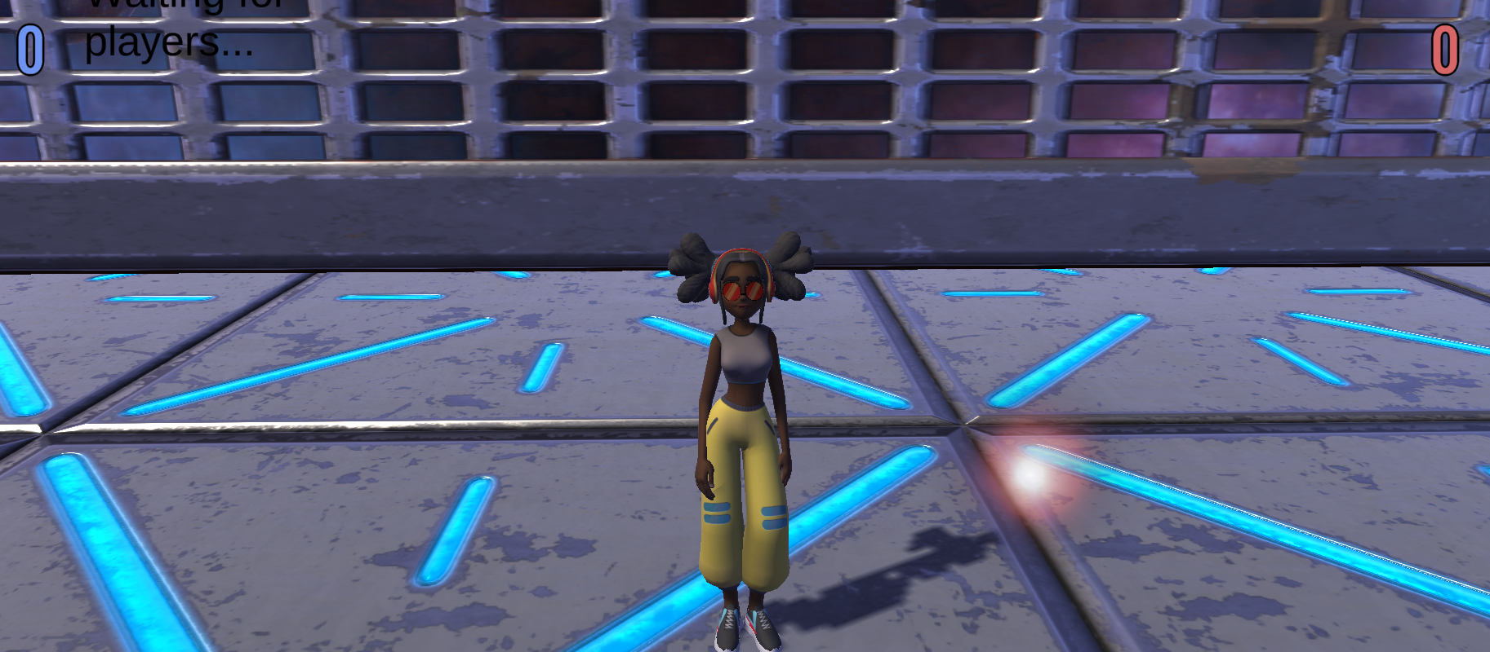

Figure 10. Screenshot of the invisibility trigger

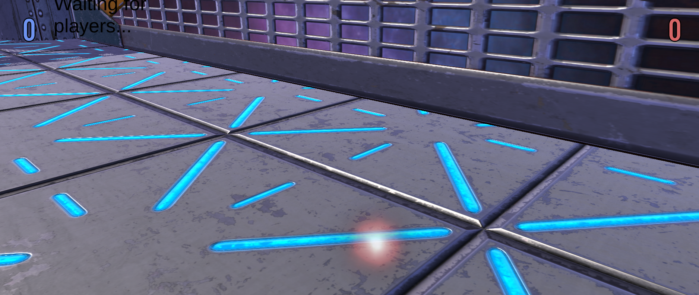

Figure 11. Screenshot of an invisible player

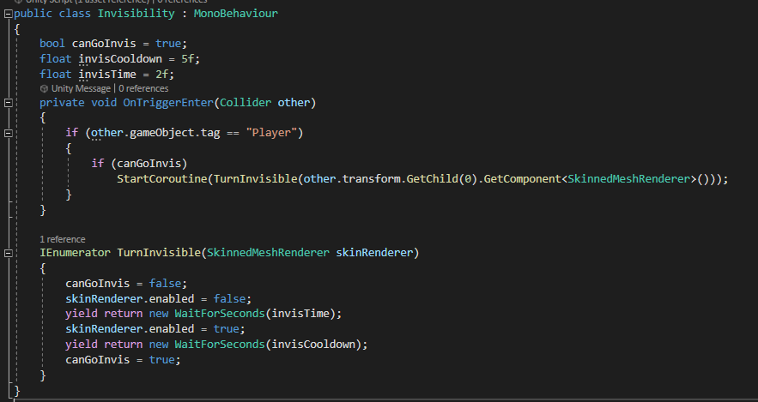

Table 6. Invisiblity code

**Laboratory work #3**

**List of tasks** (main functionality of your project)

1. New ability - Dash
2. New icons for mobile
3. Particle system

# **Solution**

## **Task #1. *Dash ability***

Added a new ability – Dash. This ability allows you to dash to one of the directions(left or right) for a quick maneuver. It has its own animation and icons to display the cooldown.

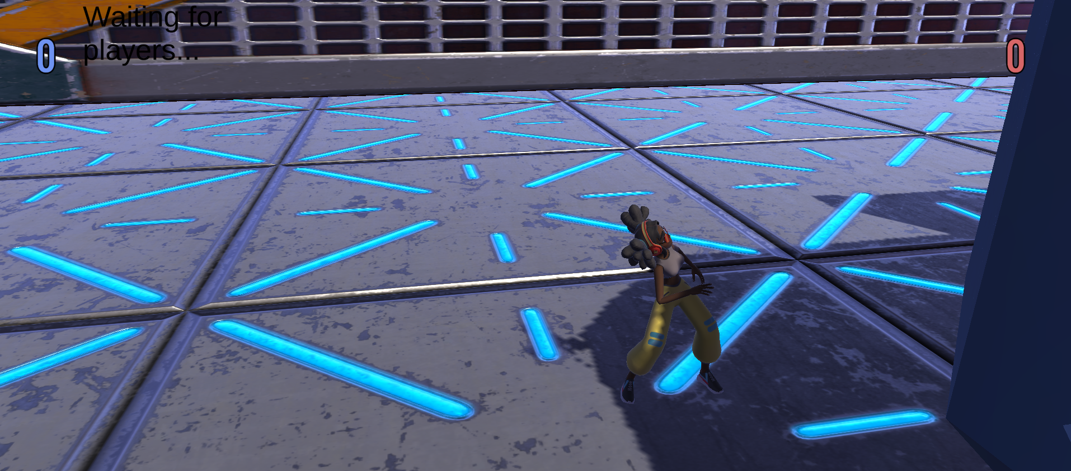

Figure 12. Screenshot of a dash ability

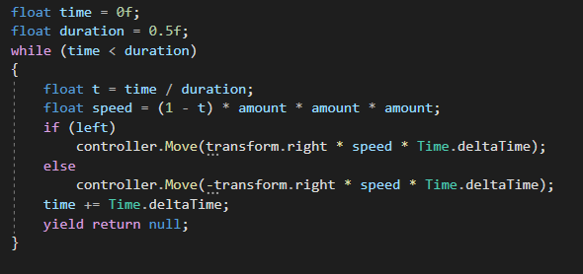

Table 7. Dash code fragment

## **Task #2. *New Icons***

Completely redid the icons for the mobile. Also the dash icons show the cooldown whenever the ability is used.

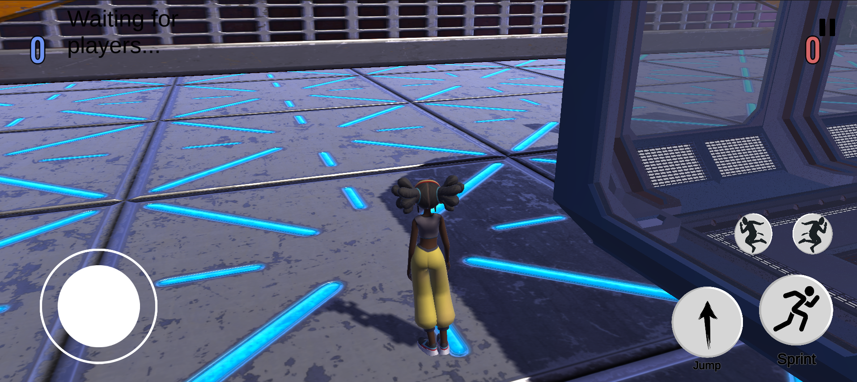

Figure 13. Screenshot of icons

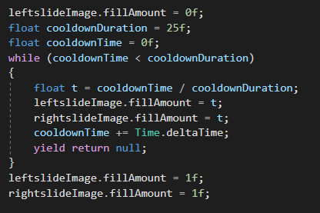

Table 8. Code of the icon cooldown

## **Task #3. *Particle system***

I have created two particle systems. One for the jump pad that I have created for this laboratory and other one for the invisibility.

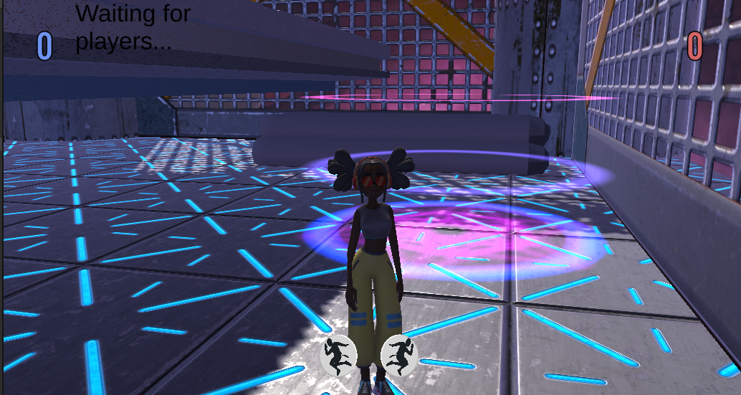

Figure 14. Screenshot of jump pad particle system

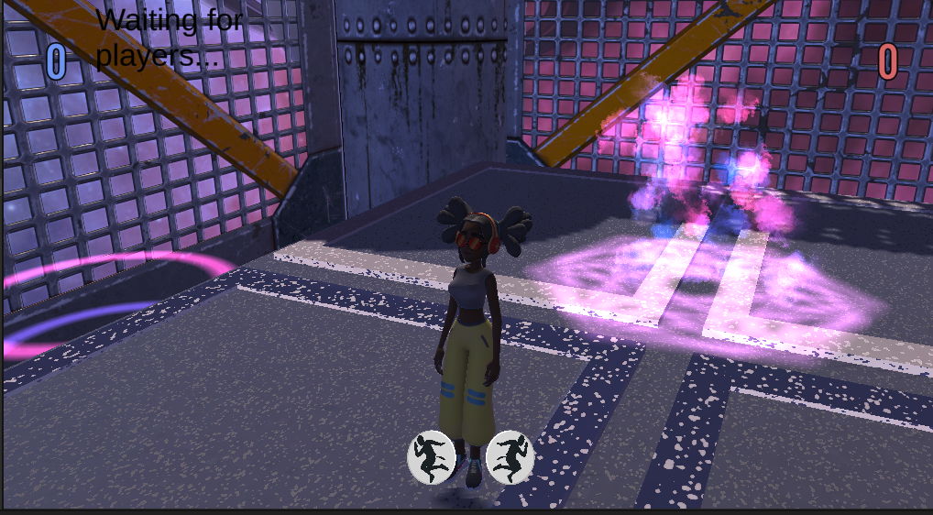

Figure 15. Screenshot of invisibility particle system

**User's manual** (for the Individual work defence)

**How to play?** To enter the game, press *PLAY*, choose *Tag* mode, and *Online*. After that you will be sent to a lobby until a player connects to your lobby.



Figure 16. Play Screen

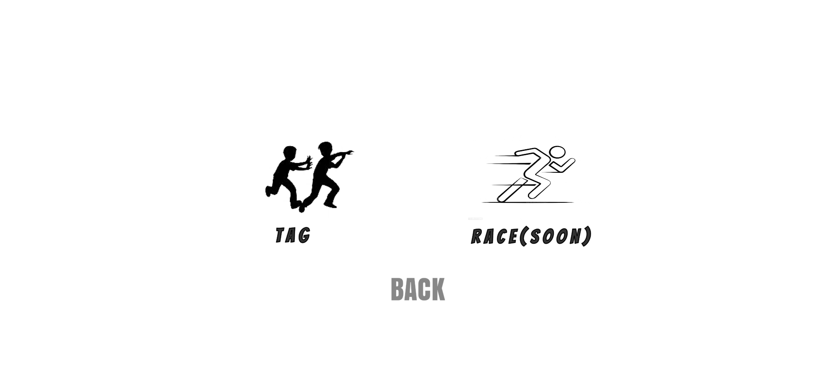

Figure 17. Game selection screen

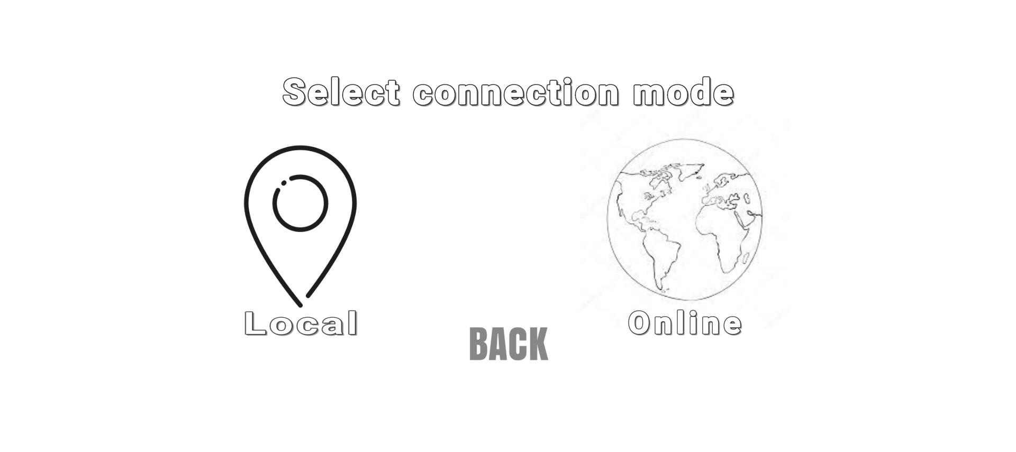

Figure 18. Connection mode screen

**Descriptions of the rules of the game**. The game goal is to catch/run away. One player has a flag and has to run away from the catcher while the other is trying to catch you. The winner is who gets to 3 points first.

**Descriptions of the controls / keys.** To play on PC, you move with WASD keys and the mouse. You can climb walls and enter the upwards stream with key F. To play on Mobile, you move with given buttons.

# **ANNEX**

https://github.com/Frozenight/towerDefense